Reaction Times and Vibrations Pattern

| Austin King  Burlington, Vermont  austin.king@mymail.champlain.edu |  | Kevin Eaton  Burlington, Vermont  kevin.eaton@mymail.champlain.edu |
| --- | --- | --- |

# ABSTRACT

Permission to make digital or hard copies of all or part of this work for personal or classroom use is granted without fee provided that copies are not made or distributed for profit or commercial advantage and that copies bear this notice and the full citation on the first page. Copyrights for components of this work owned by others than ACM must be honored. Abstracting with credit is permitted. To copy otherwise, or republish, to post on servers or to redistribute to lists, requires prior specific permission and/or a fee. Request permissions from Permissions@acm.org.

*CHI 2020, April 25–30, 2020, Honolulu, HI, USA.*

© 2020 Copyright is held by the owner/author(s). Publication rights licensed to ACM. ACM ISBN 978-1-4503-6708-0/20/04...$15.00.

DOI: <https://doi.org/10.1145/3313831.XXXXXXX>

*update the above block and DOI per your rightsreview confirmation (provided after acceptance)

Vibration-based notification systems are the most common ways of alerting users to a smart notification. Vibrations are extremely effective at alerting an individual when they have a notification because it gives them a physical alert while staying nearly silent. Vibration patterns are so effective at alerting people that they are often used for alarms in smart watches to wake users up from a deep sleep. This study is investigating the effectiveness of various vibration patterns to be applied to urgent life saving alert systems for smart watches. Drowsy driving is one of the top reasons for automobile accidents across the world. In this study we use a FitBit versa to test two different vibration patterns: a short burst vibration and a long vibration pattern.

# INTRODUCTION

Drowsy driving-related accidents often occur at high speeds. Understanding how to gain an individual's attention in the quickest way possible is important for the development of a wearable wakeup system. Participants will have a faster reaction time to prolonged vibration patterns than they will to short rapid vibrations. Rapid vibrations have periodic interruptions where no vibration is occurring because of this, the vibrations will be less likely to catch an individual's attention.   
  
H0: There is no difference in a user’s reaction when using rapid vibrations when compared to a continuous vibration.

H1: A user is more likely to react faster to a continuous vibration when compared to rapid vibrations.

# Related Works

The National Highway Traffic Safety Administration reports that drowsy driving is the cause of over 100,000 car accidents every year, 1,550 of which end in a fatality and cause 71,000 injuries (Road et al., 2019). Drowsiness related accidents are one of the top 20 reasons for car accidents, drivers don’t realize that they shouldn't be driving until it becomes too late and the accident has already occurred (Pines Salomon Injury Lawyers, APC., 2019). By using the technology that people already wear on a daily basis we are able to create a product that takes advantage of haptic feedback in order to wake a driver up from a potentially dangerous or fatal situation.

A study published in the Indian Journal of Psychological Medicine investigated the effects and prevalence of phantom ring/vibration syndrome in smartphone users. Phantom vibration (PV) syndrome is the sensations of vibration of a phone when it is not. The study found that “Sixty percent of students experienced PV, whereas 42% experienced PR and both were significantly associated with higher frequency of phone use and the use of vibration mode.” Individuals who have become accustomed to vibration-based notifications are more likely to feel the effects of phantom vibration syndrome. A significant number of heavy smartphone users are beginning to hallucinate vibration sensations when they aren’t actually happening. This is significant when trying to understand vibration recognition to wake an individual up while they are sleeping. In a world where people are sensing vibrations that aren’t actually there; a study understanding the effectiveness of different vibration patterns is extremely important to developers who are creating urgency related applications.

# Method

**Inclusion Criteria**

1. Males 18 to 25 years old
2. Individual is right handed

**Exclusion Criteria**

1. Participant is unable to wear the device, hold onto the handles, or see the black dot on the wall in front of them due to health status or functional impairment.
2. Watch is unable to fit securely with only one index finger between the band and the participants skin.
3. Individual is left handed
4. Individual is under the influence of drugs and/or alcohol

**Study Procedures**

1. Perform recruitment surveys to find candidates that are viable for this study. Ask the following questions:
   1. What is your gender?
   2. What is your date of birth?
   3. Do you have any physical impairments? If you do, please describe what portion(s) of your body is/are impaired.
2. After collecting 10 viable male subjects ask them to come in for the study.
3. Five feet off the floor, place a dime sized dot that is visible on the wall in front of the subject.

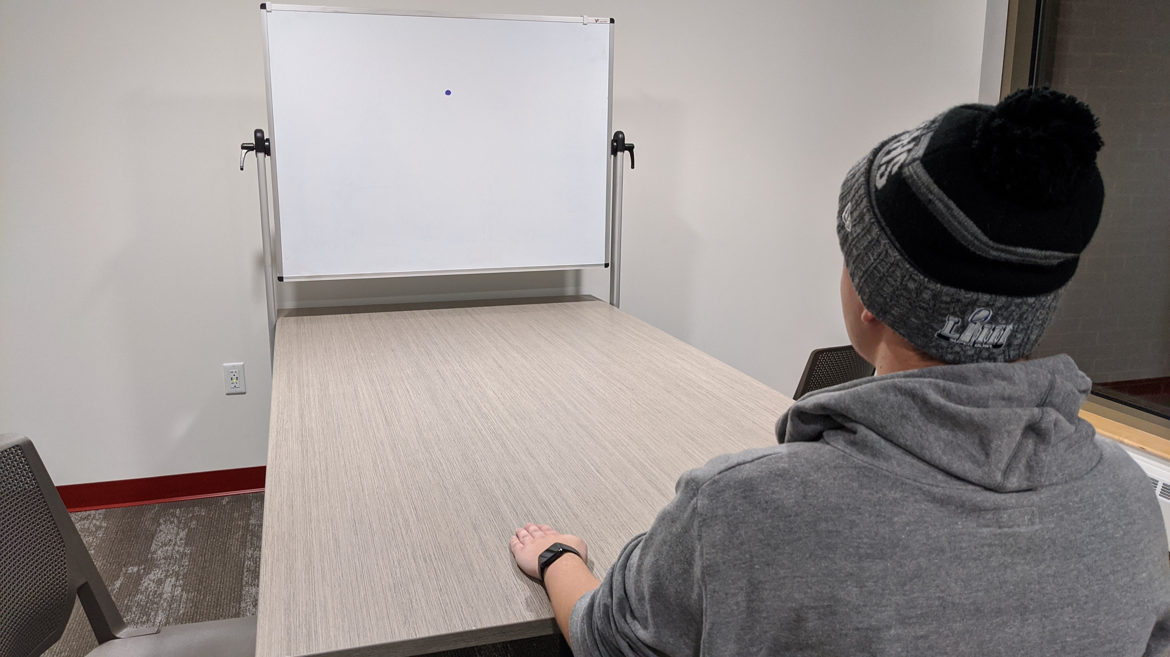

Figure 1. full study setup with example participant

1. Place two lines, one foot apart on the table where the subject will be sitting

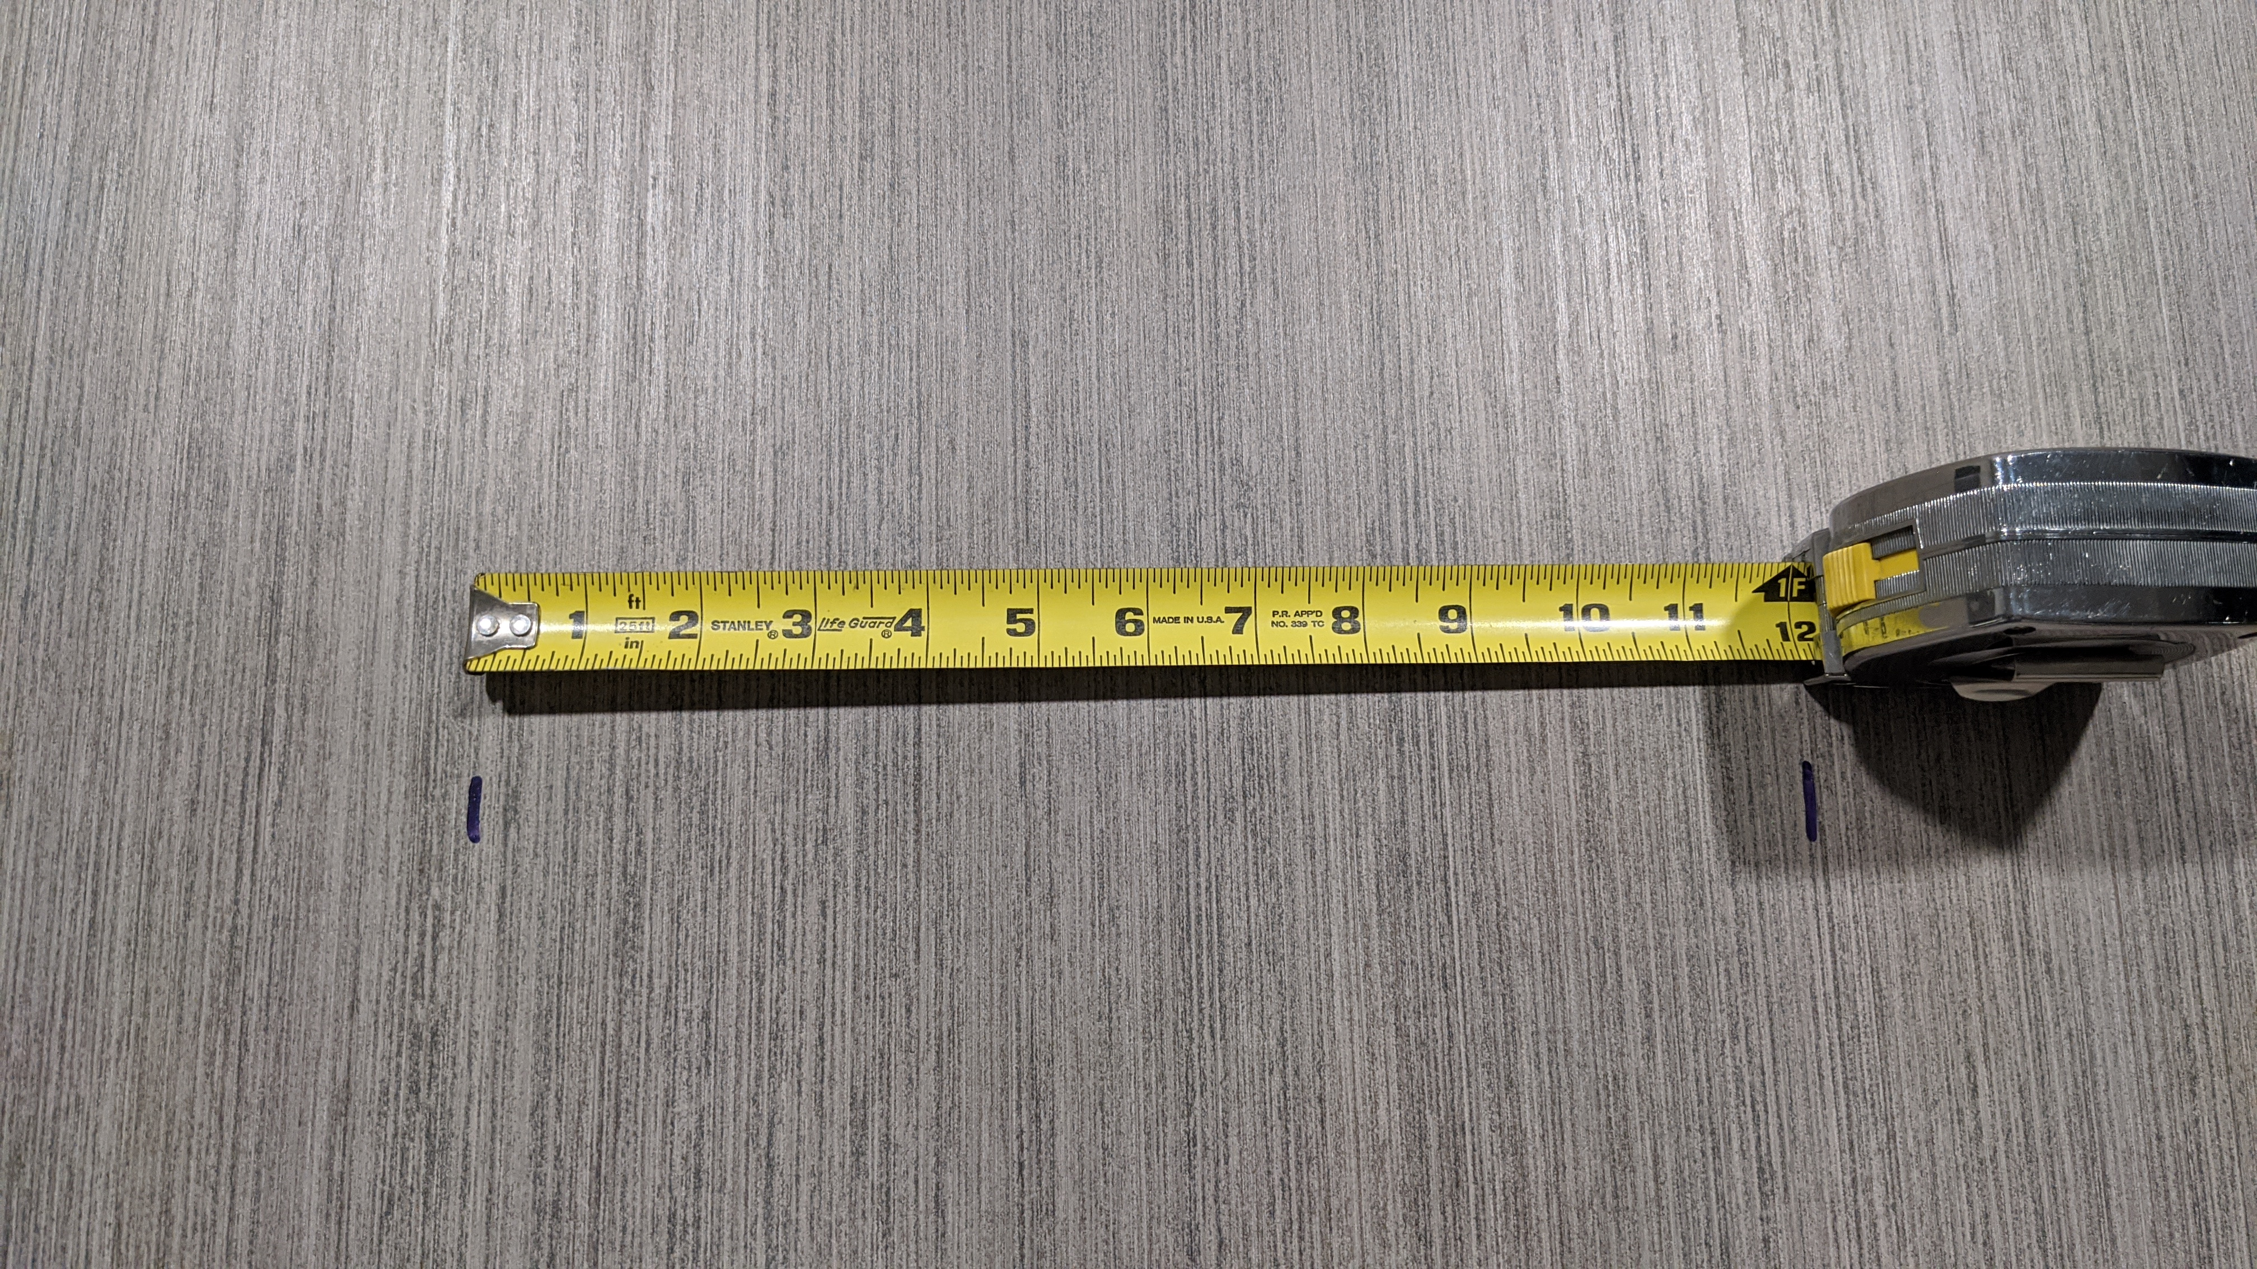

Figure 2. Place two lines, one foot apart on the table where the subject will be sitting

1. Dim the lights to 50% brightness and remove any distracting decor from the room, ensure that the walls are completely blank.
2. When the subject arrives, ask them to sit at the end of the table with the two lines in front of them.
3. After the subject has sat down, read the following script that summarizes the consent form: Thank you for participating in this study. Today we will be investigating the effects of haptic feedback through smart wearable devices. There will not be any biometric data collected during this study. The only data that will be collected during this study is time data. Here is the study consent form, please read this in full and sign if you agree to perform this study.
4. Have the subject read and sign the consent form outlining what data will be collected during the study.
   1. If the user does not sign the consent form, disqualify them from the study and thank them for their time.
5. Ask the subject to put the FitBit versa onto their left wrist
   1. Make sure the watch is secured and only one of your index fingers can fit between the subject’s skin and the watch band, if watch is too large or too small and can’t fit securely on the subject’s wrist, please disqualify the participant and thank them for their time.
6. Have the subject place their hands in the position outlined in figure 3.

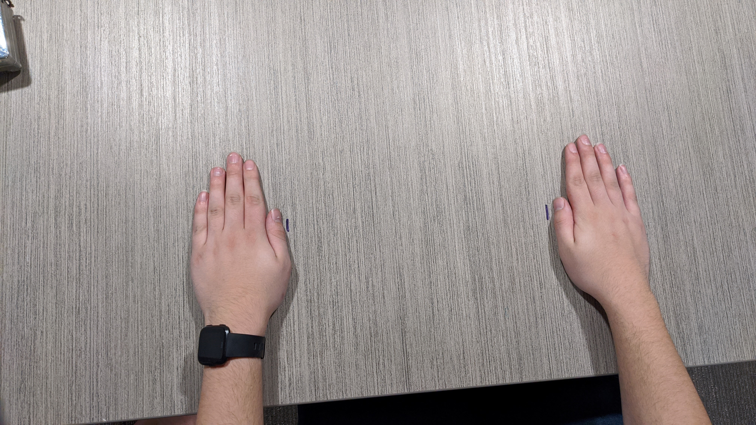

Figure 3. position participants hands with their fingers closed and the outer edge of their thumbs touching the line

1. Read the following to the subject: On your left hand, you are currently wearing a smartwatch that will randomly vibrate. When the vibration begins, a large red button will display in the middle of the screen. Keeping your left hand holding the left handle, move your right hand as quickly as possible and press the red button on the face of the watch. Please keep your hands in the current position through the entire test, only move your right hand when you feel the vibration. Do not look away from the black dot until you feel the vibration, once you feel the vibration, feel free to look wherever. Do you understand these directions? Do you have any questions?
2. Once the subject has confirmed they understand the directions, configure the watch for the subject by clicking on the button that corresponds to the subjects PID.
3. After clicking the subjects PID select the first vibration pattern (control test), tell the user to focus on the black dot and hold onto the handles, click the start button and inform the subject that the test has begun.
   1. During the test, make a note of any false responses (user moves their right hand without the vibration actually happening, or user misses the button when responding to the vibration.)
4. As soon as the subject has completed the test ask them to take the SEQ survey asking how difficult the task was.
5. Since subjects are within subjects, perform steps 10, 12, and 13 for the next vibration pattern that is associated with their group:
   1. Group “A”:
      1. continuous pattern first
      2. short pattern second
   2. Group “B”:
      1. Short pattern first
      2. Continuous pattern second

# Results

|  |  |  |
| --- | --- | --- |
| **UUID** | **Ring** | **Max Confirmation** |
| 001a | 1 | 1 |
| 001b | 1 | 1 |
| 002a | 1 | 2 |
| 002b | 1 | 1 |
| 003a | 1 | 2 |
| 003b | 1 | 1 |
| 004a | 1 | 1 |
| 004b | 2 | 2 |
| 005a | 1 | 2 |
| 005b | 1 | 2 |

Table 1. Ease of Use Question Results. Scale: 1 (Easy) to 7 (Difficult)

According to the Single Ease of Use Question, all participants found the Ring (continuous) pattern easier or equivalent to use when compared to Max Confirmation (rapid) pattern. But both vibrations and very easy for all users to use with all ratings being either a 1 or 2.

|  |  |  |
| --- | --- | --- |
| **UUID** | **Ring (MS)** | **Max Confirmation (MS)** |
| 001a | 1477 | 1325 |
| 001b | 1057 | 1464 |
| 002a | 1591 | 1495 |
| 002b | 1569 | 1742 |
| 003a | 1171 | 1044 |
| 003b | 820 | 923 |
| 004a | 942 | 1251 |
| 004b | 1889 | 2057 |
| 005a | 1254 | 1331 |
| 005b | 954 | 1027 |

Table 2. Users’ reaction times based on the pattern.

|  |  |  |
| --- | --- | --- |
|  | **Ring (MS)** | **Max Confirmation (MS)** |
| **Average** | 1272.4 | 1365.9 |

Table 3. Users’ reaction times based on the pattern.

According to the User Reaction Times Tables, user reacted to on average the Ring (continuous) pattern faster than the Max Confirmation (rapid) pattern. But viewing individual tests, some user was to react the Max Confirmation pattern faster the Ring pattern.

The reaction of each individual person was varied greatly between individual participants. Some participants had blazing fast reaction times that were under one second while most were far over one second.

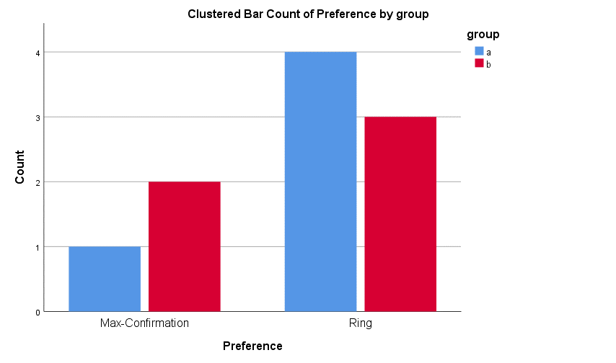

Figure 3. Preference of Vibration Pattern by Test Group

According to the Preference of Vibration Pattern By Test Group table, participants preferred the Ring Pattern when compared to the Max Confirmation Pattern. Group A participants had much stronger preference for the Ring pattern whereas Group B participants were more split on the vibration patterns.

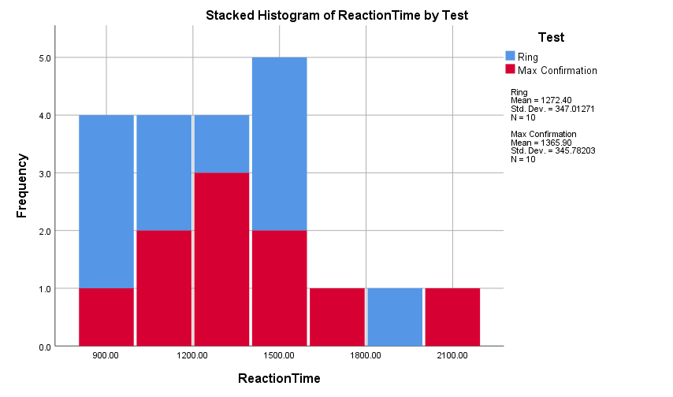

Figure 4. Stacked Histogram of Reaction Times by Vibration Pattern.

According to the Stacked Histogram of Reaction Times by Vibration Pattern, participants overall reacted faster to the Ring vibration pattern when compared to the Max Confirmation vibration pattern. The reaction times of the Ring vibration pattern did not have a normal distribution whereas the reaction times of the Max Confirmation vibration pattern had a more normal distribution.

# Discussion

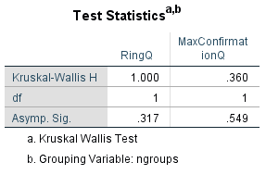

Figure 2. Results of the Kruskal Wallis Test for Ease of Use Question by Testing Group.

According to the results of the Kruskal Wallis Test, the results fail to reject the null hypothesis. The Asymptotic Significance also known as P-value was not less than 0.05 which that it was not statistically significant. This means that the relationship between reaction time and types of vibration patterns is not significant.

Although there was not statistically significant between types of vibration patterns, participants definitely had preference between the two patterns that were tested. After both tests were administered, participants were asked which vibration pattern they prefer. 70% of participants had preferred the ring or continuous vibration pattern.

The preference of the vibration pattern was also reflected in the participants reaction time to the vibration patterns. On average the participants responded to the Ring pattern in 1274.4ms and the Max Confirmation pattern at 1365.9ms. This means that participants react almost one tenth of a second faster to the Ring Pattern compared to the Max Confirmation pattern. Although this difference does not seem to be all that different, when considering the reason for this study which is waking sleeping drivers every tenth of a second counts.

**Conclusion**

In conclusion, the information found during this study will help further the understanding of haptic feedback in the HCI realm. This information can be applied to future applications that deal with life threatening or extremely important notification-based systems. We are planning on taking this data and information to develop a better version of our Keep Up application, an app that will wake people up who have fallen asleep at the wheel. We don’t want the research to end here, we decided to just investigate vibration pattern effectiveness. We would like to see more studies investigating other aspects of the long duration vibration that could affect reaction time. Overall, we see our study as the beginning to a long future of vibration-based notification studies.

# REFERENCES

1. National Safety Council. On The Road. Retrieved December 10, 2019 from https://www.nsc.org/road-safety/safety-topics/fatigued-driving
2. Pines Salomon. Top 25 Causes of Car Accidents. Retrieved December 10, 2019 from https://seriousaccidents.com/legal-advice/top-causes-of-car-accidents/
3. Sharadv Kshirsagar, Ajishg Mangot, Vasantmeghnas Murthy, Ajayh Deshmukh, and Dineshv Tembe. 2018. Prevalence and pattern of phantom ringing and phantom vibration among medical interns and their relationship with smartphone use and perceived stress. Indian Journal of Psychological Medicine 40, 5 (2018), 440. DOI:http://dx.doi.org/10.4103/ijpsym.ijpsym_141_18